Name of the project:

Name of the applicant(s):

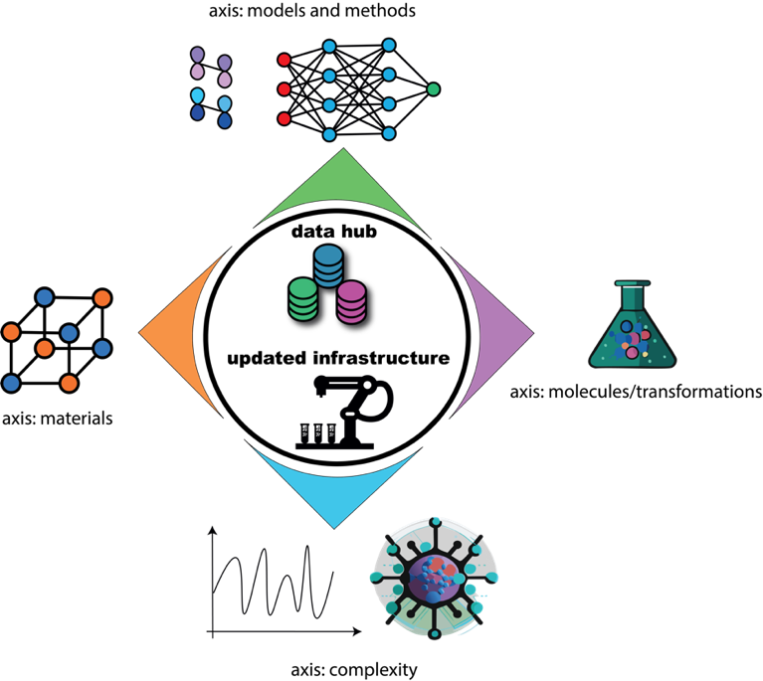

ChemAI

2025 CALL FOR PROPOSALS – INFRASTRUCTURE GRANTS

Deadline: February 21st 2025 at 17h

Decision: March-April 2025

Files should be sent to: davide.avagliano@chimieparistech.psl.eu

ELIGIBILITY

Eligible proposals are submitted by researchers affiliated with ENS, ENSCP or ESPCI. The amount of funding requested is not fixed, as long as long as it does not exceed the total envelope associated with the yearly call (€125.000). Co-funding from other sources is strongly encouraged. Possible sources of co-funding include:

- DIM MaTerRe (https://www.dim-materre.fr)
- SESAME (https://www.iledefrance.fr/aides-et-appels-a-projets/sesame-equipements-et-plateformes-scientifiques-et-technologiques)
- Other grand programmes (METASOFT, IPGG, etc.)
- Private companies
- …

Please take an active look at these funding sources before submitting an application. Projects need to be written in English; files must be named according to the following rule: PROJECTSHORTNAME_PROJECTLEADERNAME_FILENAME.

NOTE: For every (element of) the project that exceeds €5.000 in estimated cost, a devis needs to be submitted together with the proposal! For costs below this amount, rough estimates will be accepted.

EVALUATION CRITERIA

The evaluation criteria are the following:
- Scientific quality of the project. Ideally, the project constitutes a collaboration that associates the skills of at least two laboratories involved in the ChemAI grand programme.
- Potential synergies, i.e., the extent to which multiple research groups – as well as the educational programs – will be able to profit from the proposed investments, and the extent to which these investments will foster increased internal collaboration.
- Quality of the co-financing plan (if applicable).
- Compatibility of the planned infrastructure with the (planned) data hub, to ensure seamless integration of all aspects related to data collection, exchange and analysis.

TITLE OF THE PROJECT:

KEY WORDS (up to 5):

SUMMARY (max. half of an A4 page):

IDENTIFICATION OF THE PARTNERS:

 | Lab name, number and address | Team name | Name (first, last) of the project leader | Email | Phone number
Leader
Partner 1
Partner 2
…

Please attach a short resume (max 1 page, including experience, expertise, responsibilities, list up to 5 recent publications, main projects…) of each permanent researcher involved in the project
DESCRIPTION OF THE PROJECT (max. 2 pages):

POTENTIAL SYNERGIES (max. half a page):

CO-FINANCING PLAN (if applicable; max. half a page):

COMPATIBILITY WITH THE PLANNED DATA HUB (max. half a page):

