Name of the project:

Name of the applicant(s):

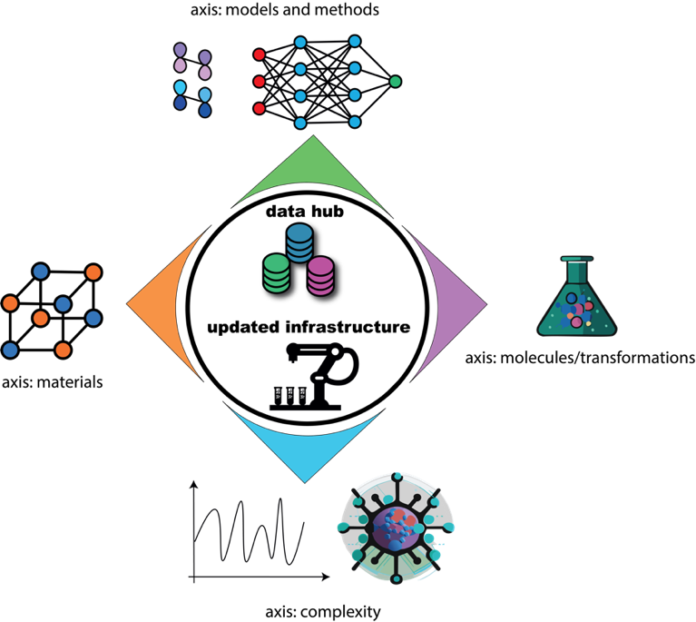

ChemAI

2025 CALL FOR PROPOSALS – PhD GRANTS

Deadline: February 21st 2025 at 17h

Decision: March-April 2025

Files should be sent to: davide.avagliano@chimieparistech.psl.eu

ELIGIBILITY

Eligible projects are carried out between researchers affiliated with ENS, ENSCP or ESPCI. Three-year contracts and standard salaries are expected, i.e., the total cost of the PhD project is capped at €125.000. Co-funding from other sources is strongly encouraged. Possible sources of co-funding include:

- DIM MaTerRe (https://www.dim-materre.fr)
- Other grand programmes (METASOFT, IPGG, etc.)
- Private companies
- …

Please take an active look at these funding sources before submitting an application. Projects need to be written in English; files must be named according to the following rule: PROJECTSHORTNAME_PROJECTLEADERNAME_FILENAME.

EVALUATION CRITERIA

The evaluation criteria are the following:
- Novelty and quality of the project. Ideally, the project constitutes a collaboration that associates the skills of at least two laboratories involved in the ChemAI grand programme.
- Alignment with the strategic goals of the ChemAI grand programme (see the scientific vision document).
- Quality of the cofinancing plan (if applicable).

DIVERSITY, EQUITY AND INCLUSION

We strongly encourage the inclusion of a concise diversity, equity and inclusion (DEI) statement in any job advertisement related to the ChemAI project, e.g.,

"We are committed to fostering an inclusive and diverse academic community. We encourage applications from individuals of all backgrounds, particularly those from underrepresented groups, and we strive to create an environment where all members feel valued, respected, and supported."
TITLE OF THE PROJECT:

KEY WORDS (up to 5):

ABSTRACT (max. half of an A4 page):

IDENTIFICATION OF THE PARTNERS:

 | Lab name, number and address | Team name | Name (first, last) of the project leader | Email | Phone number
Leader
Partner 1
Partner 2
…

Please attach a short resume (max 1 page, including experience, expertise, responsibilities, list up to 5 recent publications, main projects…) of each permanent researcher involved in the project

SCIENTIFIC DESCRIPTION OF THE PROJECT:
Maximum 3 pages; state of the art, innovative character, expected results, risks and mitigation plan should be included (references count towards the page limit).

GANTT CHART (max. half a page):

ALIGNMENT WITH THE STRATEGIC GOALS OF THE CHEMAI PROGRAMME:
How will the project contribute to the development of artificial intelligence and automation expertise within the chemistry community of PSL University (max. half a page):

CO-FINANCING PLAN (if applicable, max. half a page):

